**Steps to Capture logs of the static website from EC2 instance(Windows) to AWS S3 Bucket**

AWS Services required for this task:

1.EC2 instance(Windows)

2. IAM role

3. S3 Bucket

4. VPC

**Steps to create required infrastructure using AWS console**:

1. Create an Ec2 Instance(Windows) through the AWS management console.

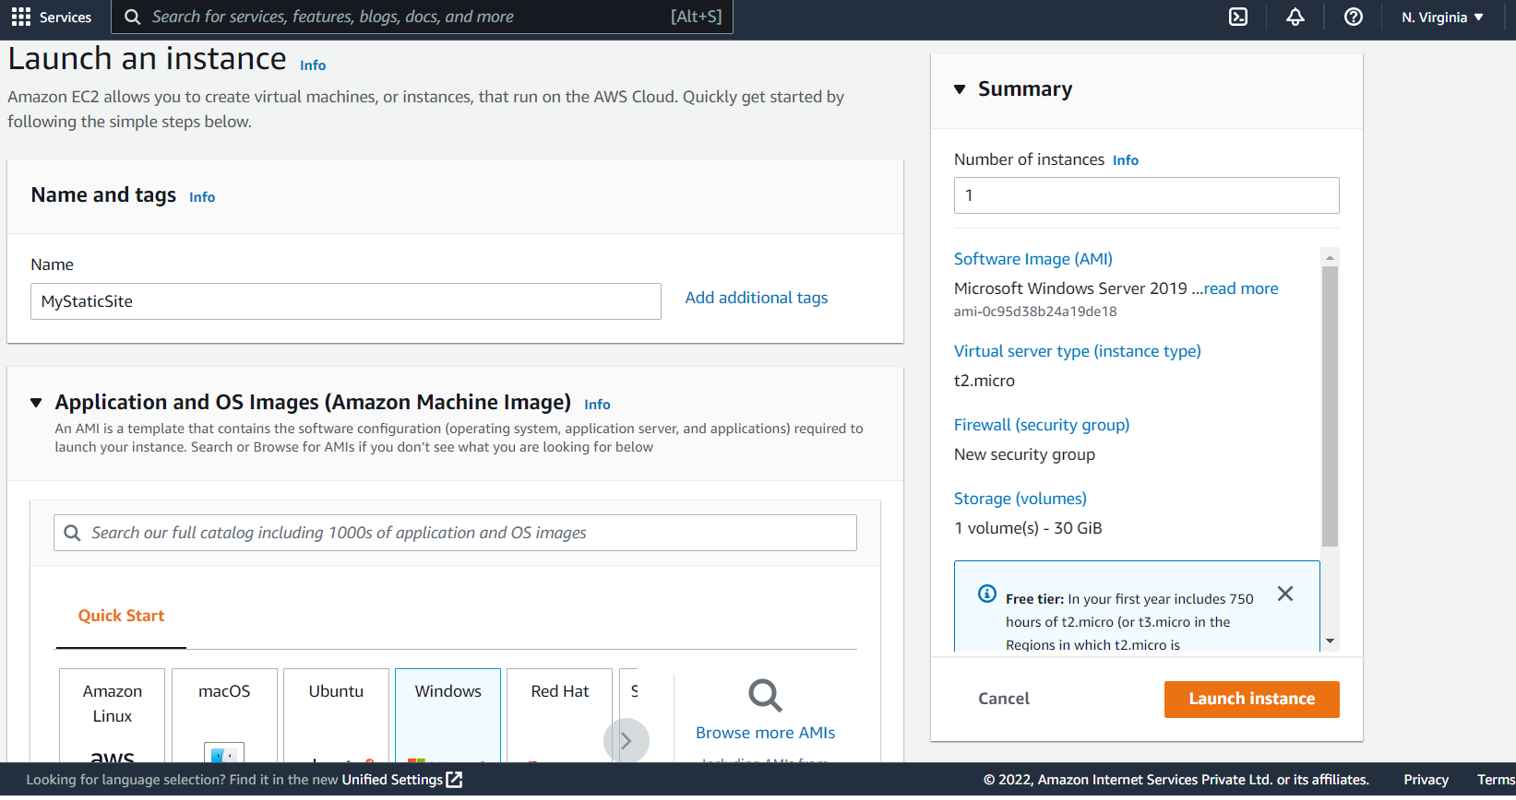

Enable the HTTP/HTTPS traffic in the network settings options while creating the EC2 instance.

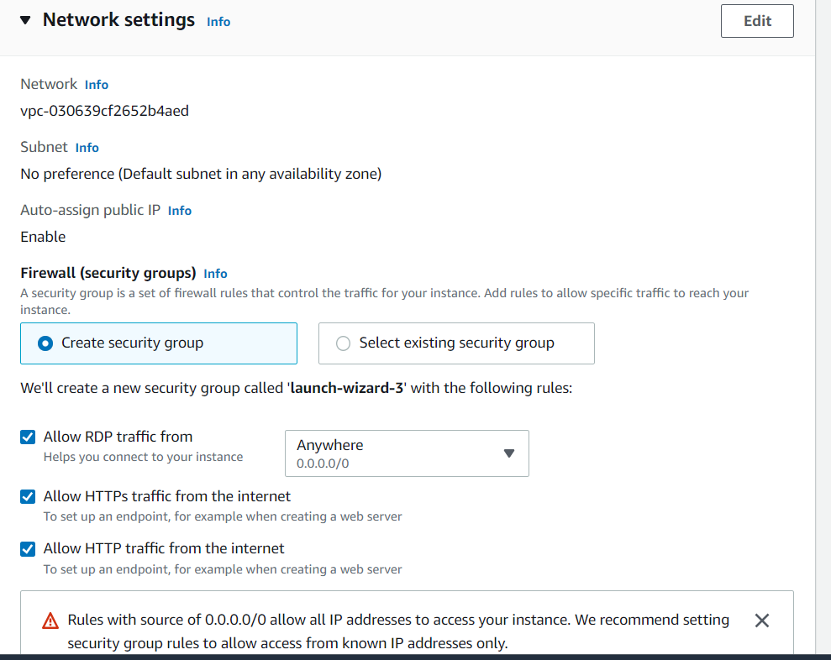

1. Create IAM Role, Attach the “**AmazonS3FullAccess**” policy to have all permissions to access S3 Buckets.

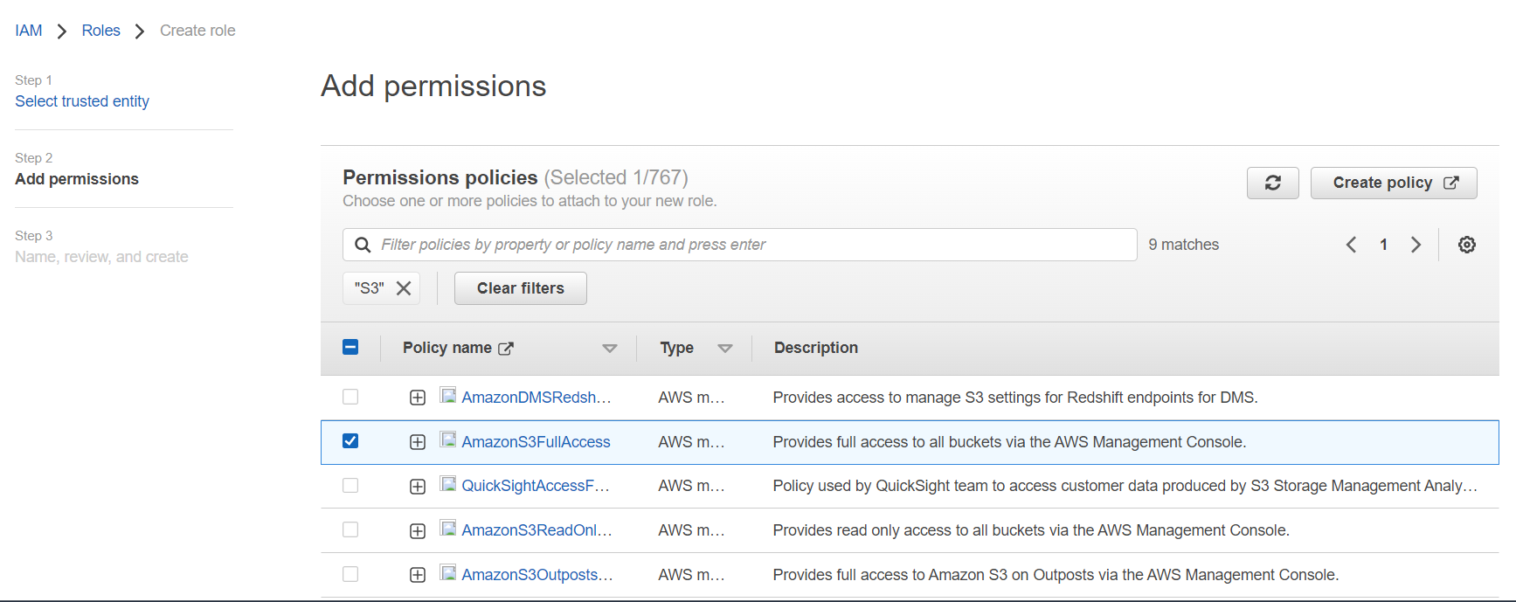

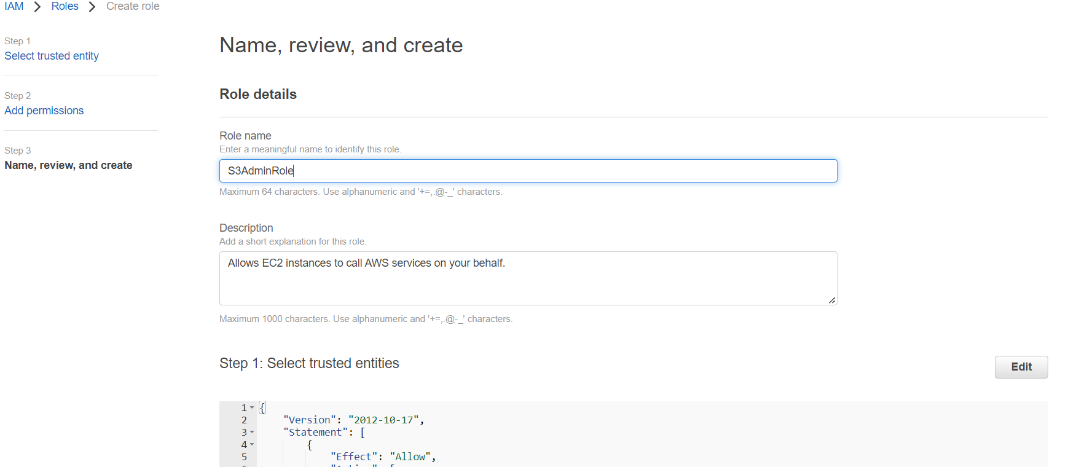

A Role named “S3AdminRole”

1. After the creation of the IAM Role “S3AdminRole”, Attach the IAM Role to the EC2 instance.

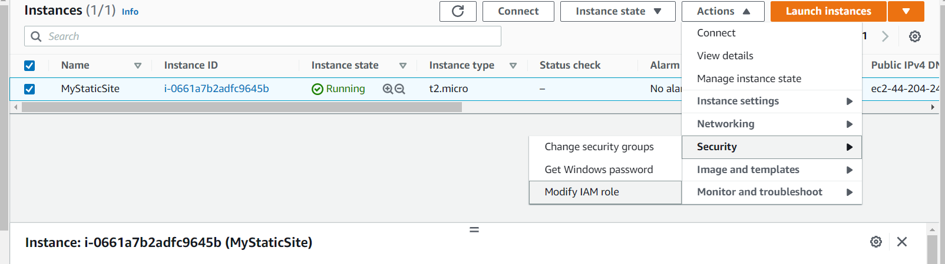

Select an instance “MyStaticSite” 🡪Actions🡪 Security🡪Modify IAM role. 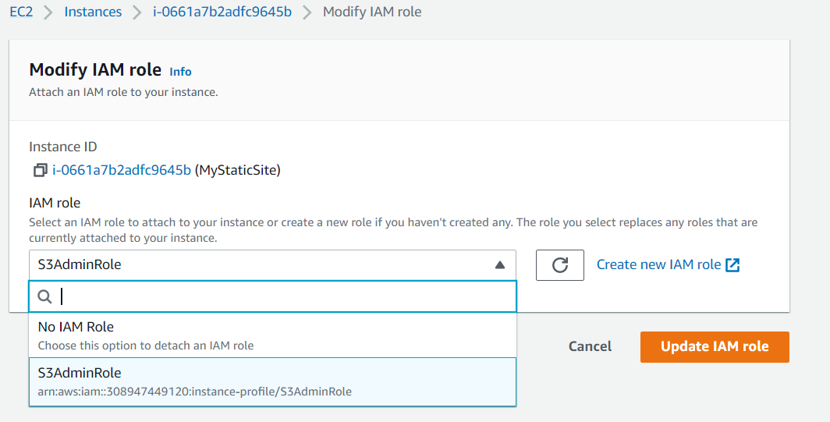

1. Create the S3 Bucket to store the logs of the static or dynamic site.

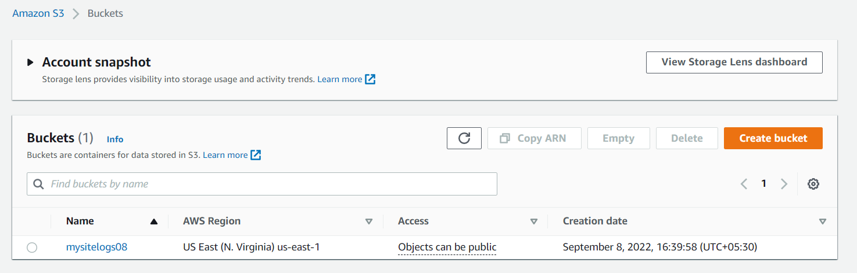

Bucket named “mysitelogs08”

**Steps to deploy a simple static site in windows IIS server:**

1. Log in to the “MyStaticSite” Windows instance using public IP address through RDP(Remote Desktop protocol)
2. Open the server manager window, and install the Web Server(IIS) in the instance.

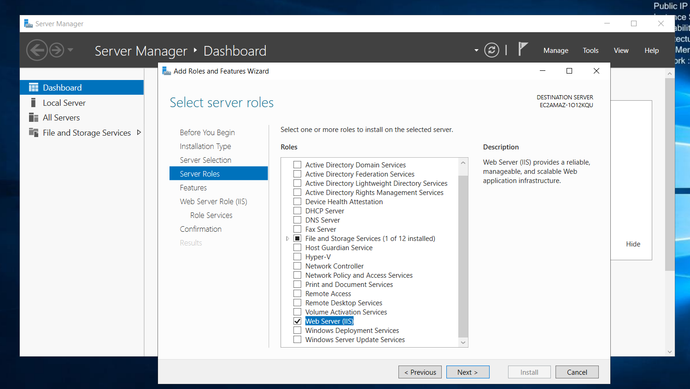

1. To Verify the installation of the IIS Web server, Browse the Public IP Address of the Ec2 instance in the browser

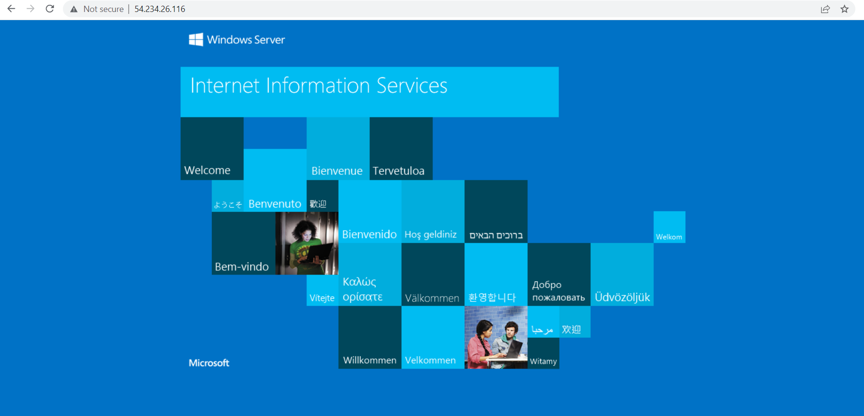

1. Download any Static Website template from the browser and place all the HTML, CSS, and Javascript files in the deployment path(“**C:\inetpub\wwwroot**”).

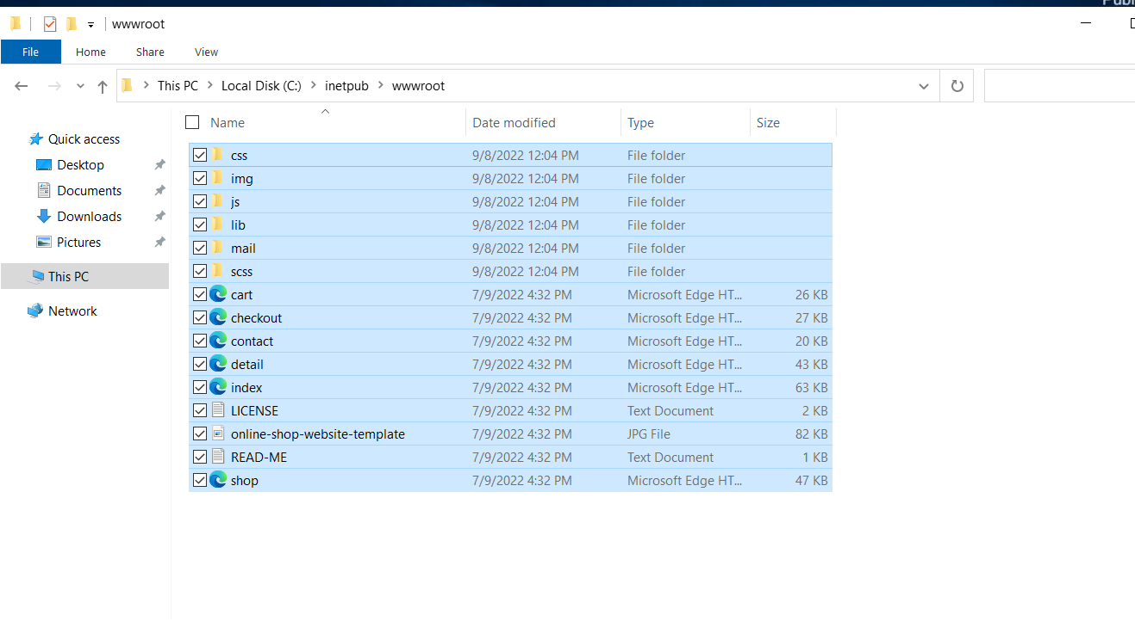

1. After Deployment, Browse the Public IP Address in the browser.



Log path : “C:\inetpub\logs\LogFiles\W3SVC1”

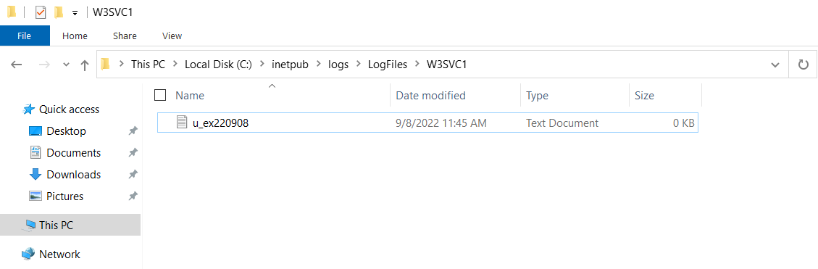

**Steps to copy the application logs from Ec2 instance to s3 bucket**:

1. Install the AWS CLI using the Command prompt in the Windows server using the command :

“**msiexec.exe /i** [**https://awscli.amazonaws.com/AWSCLIV2.msi**](https://awscli.amazonaws.com/AWSCLIV2.msi)”

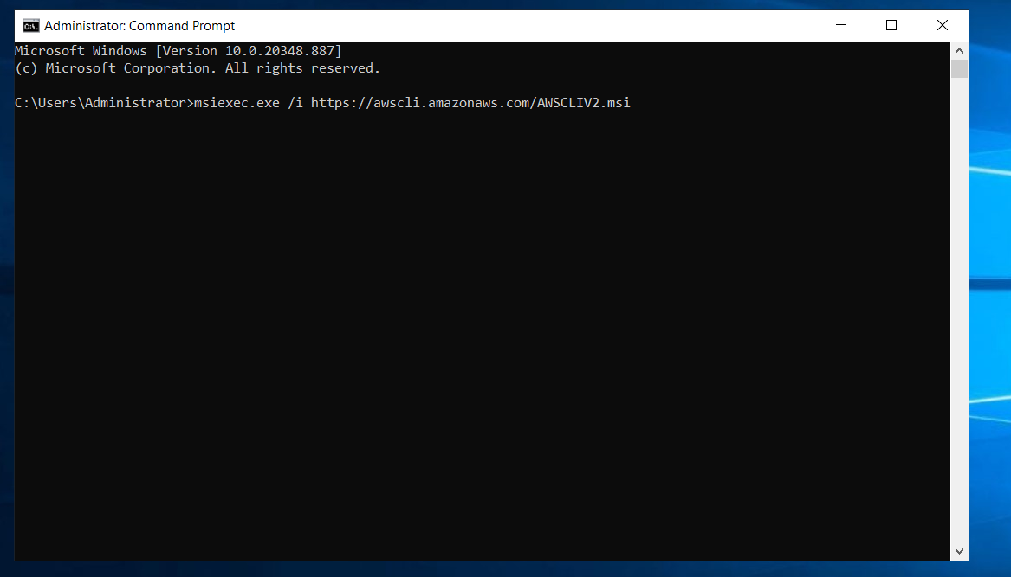

* **“AWS S3 ls”** – This command is used to list the buckets present in your AWS account
* **AWS** **–version –** To check the version of AWS CLI.

1. Use the CP command to copy the logs of the Application from the Ec2 instance to S3 Bucket.

**aws s3 cp -recursive “C:\inetpub\logs\LogFiles\W3SVC1” s3://mysitelogs08/**

**C:\inetpub\logs\LogFiles\W3SVC1 –** Log Path of Application

**s3://mysitelogs08/ --** Bucket Path

1. Create a .bat extension file and enter the command **aws s3 cp -recursive “C:\inetpub\logs\LogFiles\W3SVC1” s3://mysitelogs08/**  and save it.

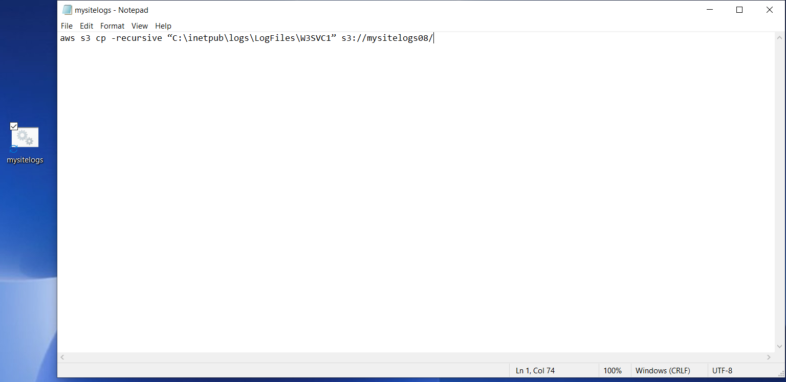

A file named “mysitelogs.bat”

1. We are going to create the task and schedule it to run the “mysitelogs.bat” file every 5min using **Task Scheduler** in the Windows instance. So every 5min, the Application logs file will be transferred from the windows server to S3 Bucket.

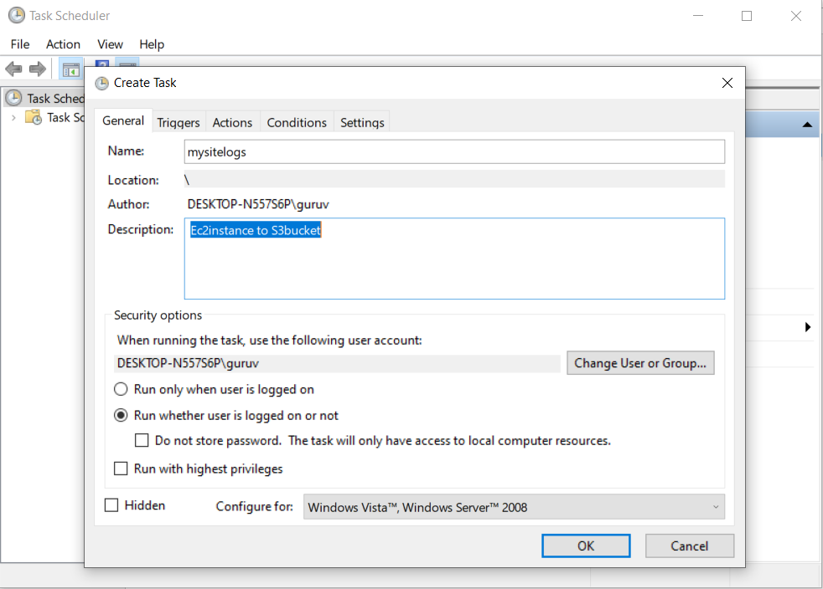

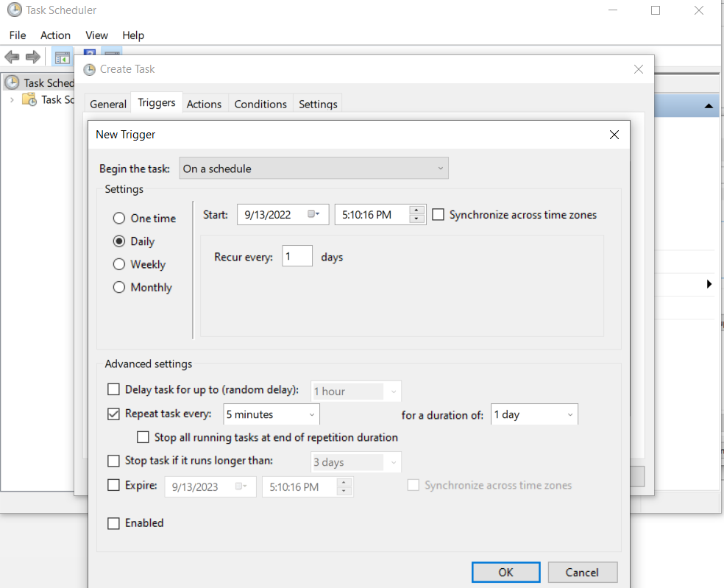

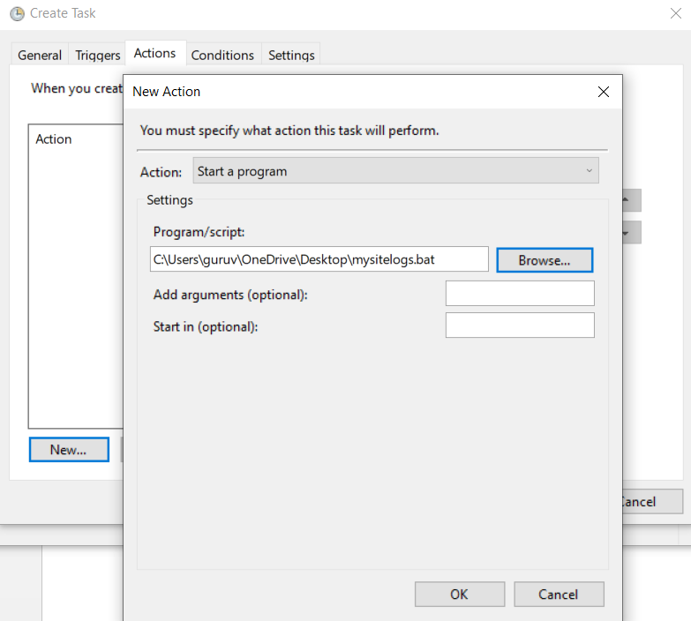

Finally, the “**mysitelogs**” task runs every 5min as per it scheduled above.

After the job is completed in the Ec2 instance, the logs file present in the location “**C:\inetpub\logs\LogFiles\W3SVC1”** will be copied to AWS S3 bucket **s3://mysitelogs08/**  file location.